Wireless Bioelectronic Technologies, Therapies, and Diagnostics
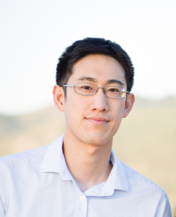

John S. Ho

Assistant Professor
National University of Singapore, Singapore
4:00 p.m – 5:00 p.m. | Mon., February 04, 2019 | DOW 1017

Abstract: Bioelectronics provide unparalleled capabilities in sensing and modulating the rich tapestry of signals regulating living systems. Their ability to target physiological signals on and within the human body, however, has so far been limited to a few anatomical regions and/or short durations of time, primarily limited by the physical inaccessibility of the underlying tissue. A key challenge over the next decade will be to expand this spatiotemporal access by orders of magnitude in order to leverage advances in microelectronics and nanotechnology for new therapies and diagnostics that address currently intractable disorders. In this talk, I will describe our work on wireless technologies for bioelectronics and their applications in medicine. I will present approaches to wirelessly power and extract data from deeply implanted microdevices that are not accessible by conventional means, and discuss how these technologies can enable new therapies, including a targeted form of cancer treatment based on the wireless delivery of light. I will also highlight an approach to efficiently and securely interconnect wireless networks of wearable sensors using metamaterial textiles, inspired by the way that light propagates on metallic surfaces.

Bio: John S. Ho is an assistant professor in the Department of Electrical and Computer Engineering at the National University of Singapore. He received his PhD in electrical engineering at Stanford University under Prof. Ada Poon where he was a National Defense Science and Engineering Graduate Fellow. He is a recipient of the National Research Foundation Fellowship and the NUS Young Investigator Award, and has appeared on the MIT TR35 Innovator Under 35 Asia and Forbes 30 Under 30 Asia lists. His current research interests are centered on the development of wireless bioelectronic systems and their applications to medicine.

